project #1

|  |  |  |  |  |
| --- | --- | --- | --- | --- |
|  |  |  |  |  |
|  |  |  |  |  |

|  |  |
| --- | --- |
| Project name | **Online Shopping In #C** |

**Start with the greatest name of ALLAH who is the kindest and the most merciful.**

In our project, we used functions called: library, main, loop, switch case, and the array we did every single thing which our instructor assigned us to add.

* Our project is based on online shopping

As everybody knows this era depends on online shopping nowadays everyone is shopping online this was our aim to create a project.



* Specialties of our project

Our project starts with a name and then asks about things that you want to purchase as in one click cart this also welcomes you to shopping store.

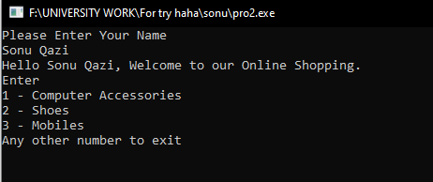

After selecting your options as we selected 3 called mobiles it gives you display about pricing and product name.

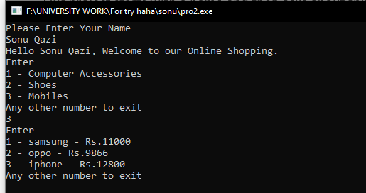

As I selected 3 called iPhone you can see product details in your cart And you can add and delete your product and quantity after adding to the cart then the program will as you to confirm or delete your purchase

After adding to your cart our program also gives you information about yourself (For example) your name your product name and pricing also quantity how many products you have added to your cart

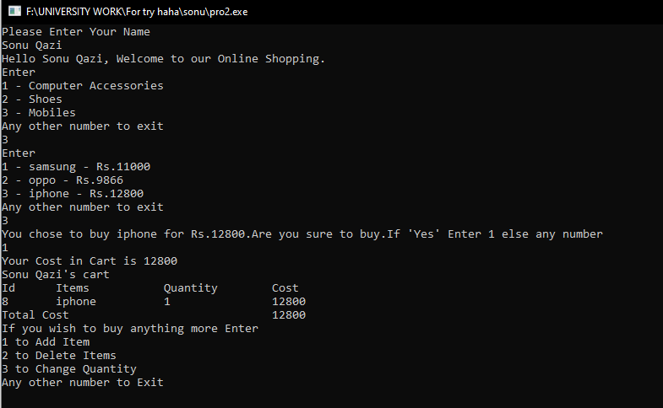

If I want to add one more product to my cart and I want to double my iPhone quantity I will press 1 to add and 3 to change in quantity Lets see how it happens

